**Concepts of Operating System**

**Assignment 1**

**Problem 1: Read the instructions carefully and answer accordingly. If there is**

**any need to insert some data then do that as well.**

**a) Navigate and List:**

**a. Start by navigating to your home directory and list its contents. Then, move into a**

**directory named "LinuxAssignment" if it exists; otherwise, create it.**

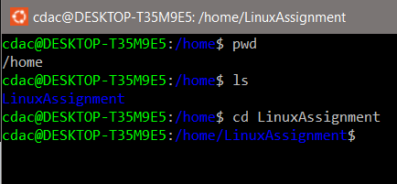

**b) File Management:**

**a. Inside the "LinuxAssignment" directory, create a new file named "file1.txt". Display its**

**contents.**

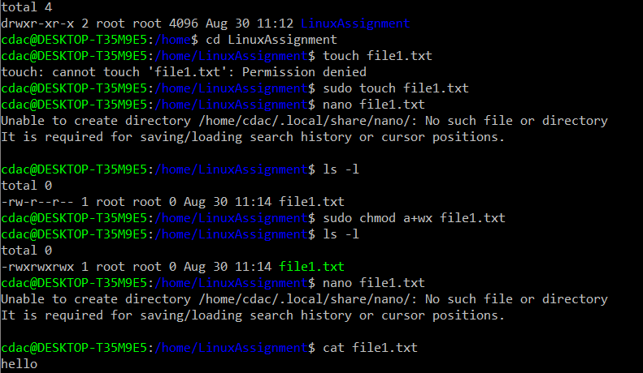

**c) Directory Management:**

**a. Create a new directory named "docs" inside the "LinuxAssignment" directory.**

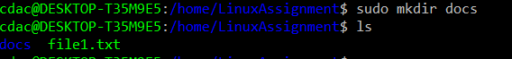

**d) Copy and Move Files:**

**a. Copy the "file1.txt" file into the "docs" directory and rename it to "file2.txt".**

**{ Cp file1.txt docs}**

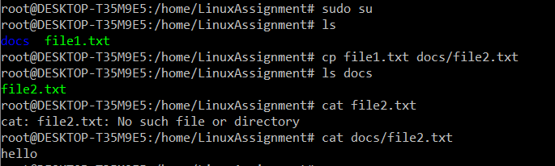

**e) Permissions and Ownership:**

**a. Change the permissions of "file2.txt" to allow read, write, and execute permissions for**

**the owner and only read permissions for others. Then, change the owner of "file2.txt" to**

**the current user.**

**{ chmod u+rwx filename**

**and for removal**

**chmod g-rwx filename**

**chmod o-rwx filename }**

**{ chown ownerName file2.txt } , { Whoami }**

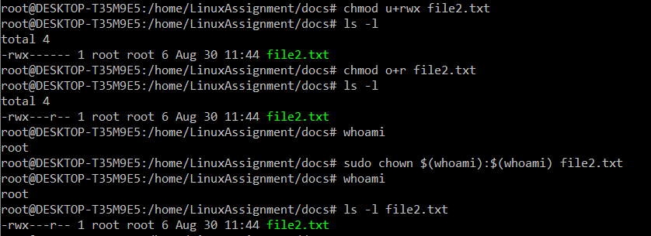

**f) Final Checklist:**

**a. Finally, list the contents of the "LinuxAssignment" directory and the root directory to**

**ensure that all operations were performed correctly.**

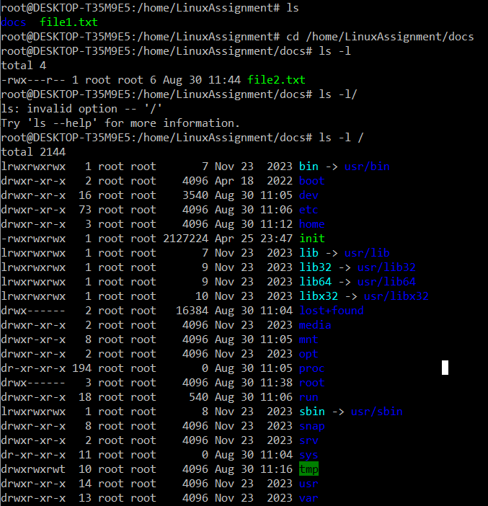

**g) File Searching:**

**a. Search for all files with the extension ".txt" in the current directory and its subdirectories.**

**{ find -name "*. txt" }**

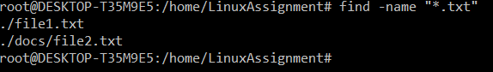

**b. Display lines containing a specific word in a file (provide a file name and the specific**

**word to search).**

**{ grep -i “hello” filename }**



**h) System Information:**

**a. Display the current system date and time.**



**i) Networking:**

**a. Display the IP address of the system.**



**b. Ping a remote server to check connectivity (provide a remote server address to ping).**

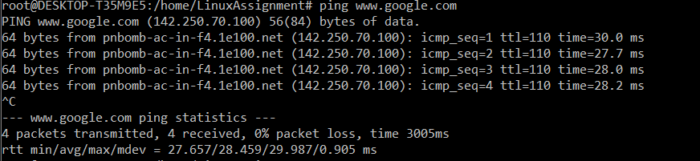

**j) File Compression:**

**a. Compress the "docs" directory into a zip file.**



**b. Extract the contents of the zip file into a new directory.**

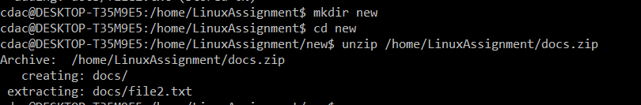

**k) File Editing:**

**a. Open the "file1.txt" file in a text editor and add some text to it.**



**b. Replace a specific word in the "file1.txt" file with another word (provide the original**

**word and the word to replace it with).**

**Problem 2: Read the instructions carefully and answer accordingly. If there is**

**any need to insert some data then do that as well.**

**a. Suppose you have a file named "data.txt" containing important information. Display the**

**first 10 lines of this file to quickly glance at its contents using a command.**

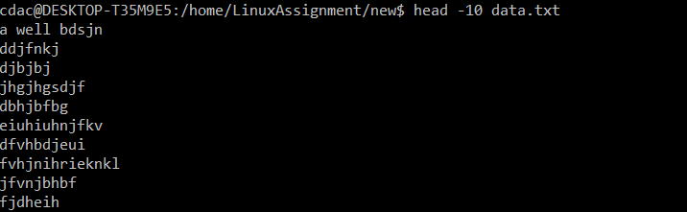

**b. Now, to check the end of the file for any recent additions, display the last 5 lines of**

**"data.txt" using another command.**

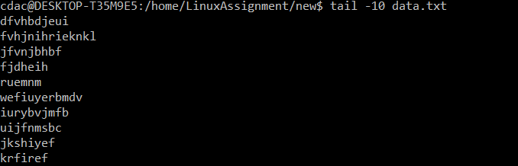

**c. In a file named "numbers.txt," there are a series of numbers. Display the first 15 lines of**

**this file to analyze the initial data set.**

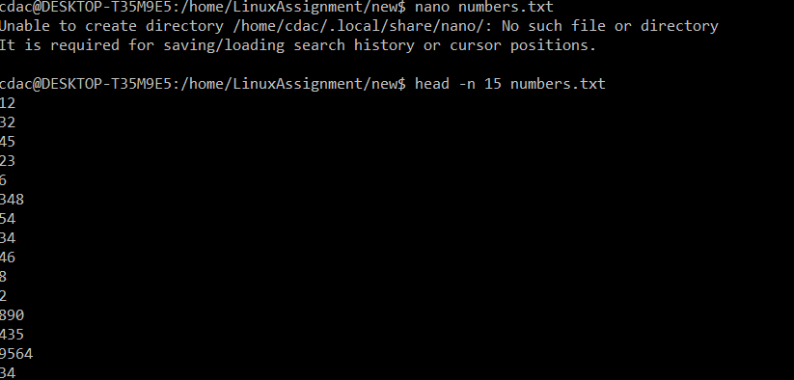

**d. To focus on the last few numbers of the dataset, display the last 3 lines of "numbers.txt".**

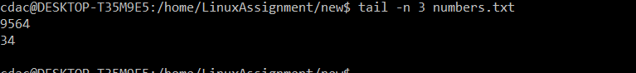

**e. Imagine you have a file named "input.txt" with text content. Use a command to translate**

**all lowercase letters to uppercase in "input.txt" and save the modified text in a new file named "output.txt."**

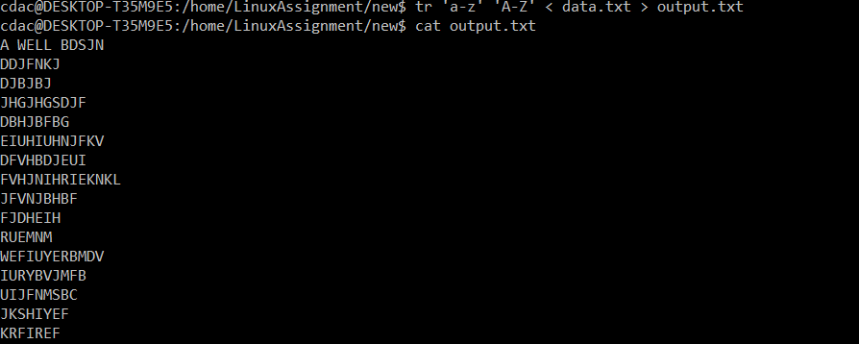

**f. In a file named "duplicate.txt," there are several lines of text, some of which are**

**duplicates. Use a command to display only the unique lines from "duplicate.txt."**

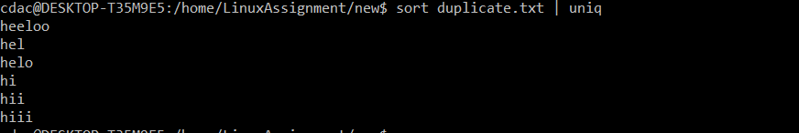

**g. In a file named "fruit.txt," there is a list of fruits, but some fruits are repeated. Use a**

**command to display each unique fruit along with the count of its occurrences in**

**"fruit.txt."**

